

Test Documentation

Integrator with state boundaries

Version: 1.1

|  |  |  |
| --- | --- | --- |
| Project Name | Thales | |
| Project Leader | Jinwei Zhou | |
| Person in Charge | Nina Družetić | |
| Created | 03.05.2019 22:51:00 | |
| Last Modified | 03.05.2019 23:04:00 | |
| Status | x | in process  submitted  completed |
| File Storage Path | C:...\Project\test | |

1. Change Directory

|  |  |  |  |  |  |  |
| --- | --- | --- | --- | --- | --- | --- |
| Changes | | | Chapter | Version History | Author | State |
| No. | Date | Version |
|  | 03.05.2019 | 1 | All |  | Nina Družetić | In process |
|  | 07.05.2019 | 1.1 | Test cases |  | Nina Družetić | submitted |
|  |  |  |  |  |  |  |
|  |  |  |  |  |  |  |
|  |  |  |  |  |  |  |

1. Test Directory

|  |  |  |  |  |
| --- | --- | --- | --- | --- |
| Date | Proofed Version | Comments | Author | Product State |
| 03.05.2019 | 1 |  |  |  |
|  |  |  |  |  |
|  |  |  |  |  |
|  |  |  |  |  |
|  |  |  |  |  |

1. Goal

The goal of this document is to describe function „Integrator with state boundaries“ and to explain the reasoning behind the test design which was developed. If the function is developed according to the specifications the test will have a value of True. In this specific document, the function was described using acceleration and velocities but the function (integrator) can be used for other systems and examples too.

1. System description

Integrator with state boundaries is used to calculate current velocity if initial velocity, current acceleration and minimum, and maximum velocity are given. Minimum and maximum velocity represent state boundaries which shouldn't be crossed in the simulated system. Every time calculated velocity is greater then maximum velocity it becomes maximum velocity or if it is lower then minimum velocity it becomes minimal velocity.

The integral of the acceleration function a(t) is the velocity function v(t); that is, the area under the curve of acceleration vs. time (a vs. t) graph corresponds to velocity.

$v= v_{0}+ \int_{0}^{t}{a\left(t\right)dt}$

Integration method used in the function is the Forward Euler method. With the first time step, block state n = 0, with either initial output y(0) = IC or initial state x(0) = IC, depending on the Initial condition setting parameter value.

For a given step n > 0 with simulation time t(n), Simulink® updates output y(n) as follows:

$$y\left(n\right)=y\left(n-1\right)+K*\left[t\left(n\right)-t\left(n-1\right)\right]*u(n-1)$$

Source : <https://www.mathworks.com/help/simulink/slref/discretetimeintegrator.html>

Sample time is constant throughout the simulation and represented with Ts, so the formula above can be representend as:

$$y\left(n*Ts\right)=y\left(\left(n-1\right)*Ts\right)+K*Ts*u(\left(n-1\right)*Ts)$$

Figure 1 shows acceleration and velocity graph if acceleration is input and velocities are calculated according to the specifications (with having minimum, maximum and initial velocity in mind).A picture containing object

Description generated with very high confidence

Figure 1 : Acceleration and velocities graph

1. Test design:

The test is designed to check if the function is working exactly how it is described above. In order to validate function four requirements have to be satisfied (requirements are listed below).

Acceleration is defined as :

$$a= \frac{dv}{dt}$$

Since measurnments are taken every Ts seconds, acceleration can be expressed as:

$$a= \frac{∆v}{∆t}=\frac{v\left(\left(n+1\right)*Ts\right)-v(n*Ts)}{t\left(\left(n+1\right)*Ts\right)-t(n*Ts)}= \frac{v\left(n+1\right)-v(n)}{Ts}$$

Figure 2 explains how the test is designed. Velocity is used to calculate initial acceleration but since integrator has state boundaries calculated acceleration and input acceleration to the function are not necessarily the same. Whenever the velocity is equal to the maximum or minimum velocity there is no further increase or decrease of velocity which leads to the conclusion that acceleration is zero for at least one time step Ts.

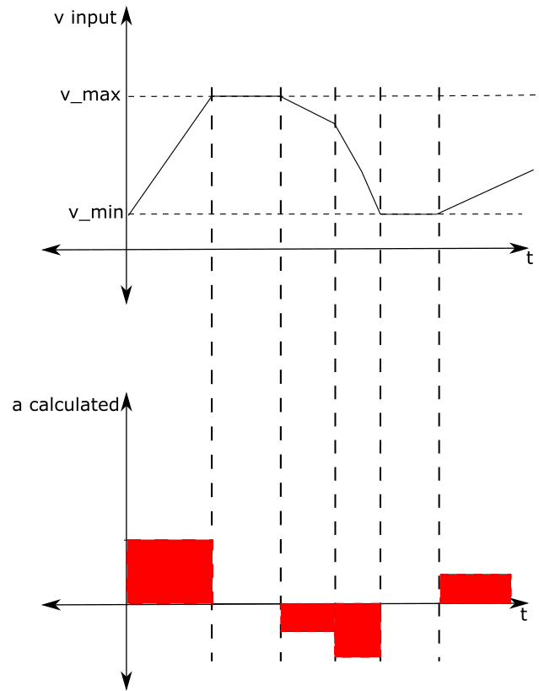

Figure 2: Acceleration derived from simulated velocity

Figure 3 shows the difference between the initial acceleration and the one calculated using the test.

A close up of a logo

Description generated with high confidence

Figure 3: Difference between the input acceleration and the calculated acceleration

1. Test requirements

R1: If the simulated velocity is equal either to the minimal or maximal velocity, simulated acceleration for that time step is equal to zero. <R1.slx>

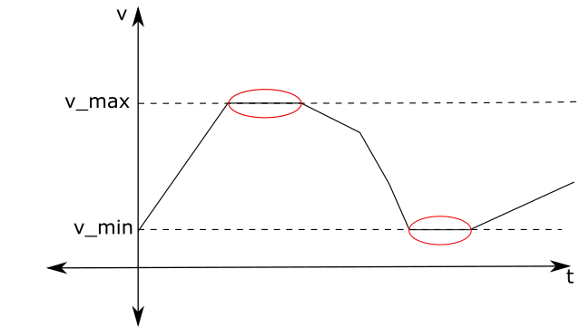

R2: If simulated velocity is less then maximum velocity and grater than minimal velocity, acceleration is derivative of simulated velocity. <R2.slx>

A picture containing object

Description generated with high confidence

Please note:

Global truncation error in the Euler Forward integration is proportional to the time step (Ts). Since there is an error in numerical calculations, the values have to be almost equal, or in mathematical words:

$$a_{int}-a_{der}=±ε$$

where Ɛ→0

R3: If requirement R1 is true then requirement R2 has to be false. If requirement R2 is true then requirement R1 has to be false. <R3.slx>

If the function is designed correctly result of the test(T1) must be True. Or written down using boolean language :

T1 = R3 = R1 XOR R2

Requirements R1 and R2 can be checked together with XOR. XOR returns true when only one input is true.

R1 R2 R1 XOR R2

0 0 0

0 1 1

1 0 1

1 1 0

1. Test cases

In order to check if the function is working correctly and it covers all of the cases, we will do several kinds of cases for stimuli.

Case 1:

Case one simulates highway speeding up in a positive direction. All of the input values are constants. Minimum, maximum velocities and acceleration are positive values. The initial value of the velocity is between the minimum and the maximum value. The body accelerates until it reaches the maximal allowed velocity and then continues moving with that velocity.

Case 2:

Case two simulates highway speeding up in a negative direction. All of the input values are constants. Minimum, maximum velocities and acceleration are negative values. The initial value of the velocity is between the minimum and the maximum value. The body deaccelerates until it reaches the minimal allowed velocity and then continues moving with that velocity.

Case 3:

Case three simulates highway slowing down in a positive direction. All of the input values are constants. Minimum and maximum velocities are positive values and acceleration is a negative value. The initial value of the velocity is between the minimum and the maximum value. The body deaccelerates until it reaches the minimal allowed velocity and then continues moving with that velocity.

Case 4:

Case four simulates highway slowing down in a negative direction. All of the input values are constants. Minimum and maximum velocities are negative values and acceleration is a positive value. The initial value of the velocity is between the minimum and the maximum value. The body accelerates until it reaches the maximal allowed velocity and then continues moving with that velocity.

Case 5:

Case five simulates the start of the movement in a positive direction. All of the input values are constants. Acceleration is a positive value. The initial value of the velocity is between the minimum and the maximum value. The body accelerates until it reaches the maximal allowed velocity and then continues moving with that velocity.

Case 6:

Case six simulates tehe start of the movement in a negative direction. All of the input values are constants. Acceleration is a negative value. The initial value of the velocity is between the minimum and the maximum value. The body deaccelerates until it reaches the minimal allowed velocity and then continues moving with that velocity.

Case 7:

Case seven simulates the change of the acceleration in a positive direction. The initial value of the velocity is between the minimum and the maximum value. The body first accelerates until it reaches the maximal allowed velocity and then deaccelerates.

Case 8:

Case eight simulates the change of the acceleration in a negative direction. The initial value of the velocity is between the minimum and the maximum value. The body first deaccelerates until it reaches the minimal allowed velocity and then accelerates.

1. Table of Contents

1. Change Directory 2

2. Test Directory 2

3. Goal 2

4. System description 2

5. Test design: 3

6. Test requirements 5

7. Test stimuli 6

8. Table of Contents 8